 |  | 
 | LG 3600
 | 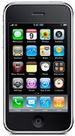 | Description  FM Radio and FM as alarm, 65000 color display, 32 polyphonic ring tone, Reliance Mobile World, Speaker, Hindi user interface and Hindi SMS  STORE PRICE: Rs 1,600 /-  ONLINE PRICE: Rs 1,600 /-
Brand : LG
Model Name : 3600
Released Year : N/A
Phone Memory : No
External Memory : No
Colors : N/A
Form : Bar
Dimensions : 101 mm x 46mm x 13.9 mm
Weight : 80 g

